Cartoon effect self potrait  
(MID-TERM EVALUATION)

*VAIBHAV GANDHI*

R100218070

500067190

Contents

PHASE 1: GIMP

CARTOON EFFECT SELF POTRAIT

STEPS

IMPACT OF CHANNELS

Phase1: GIMP

**CARTOON EFFECT SELF POTRAIT**

1. Open the image you want to convert.
2. Select Path Tool.
3. Create New Transparent Layer.
4. Rename the new layer as Cartoon Layer.
5. Draw the path around the subject using path tool.

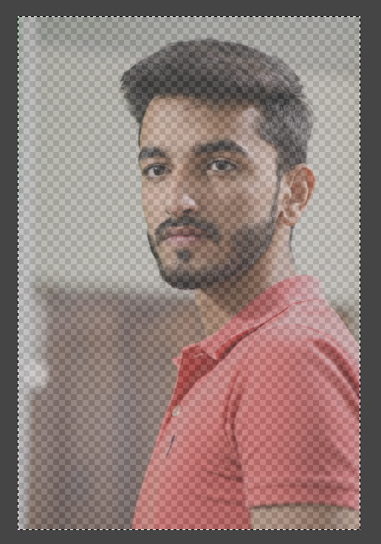

1. Ctrl + Click to finish the loop.
2. Right click inside the image and make path into selection.
3. Select bucket fill tool.
4. Select color picker tool.
5. Select color of the skin.
6. Skin color is selected as foreground color.
7. Fill it inside the selection with bucket fill tool.
8. Hide the Cartoon layer.
9. Draw the path again for hair.
10. It’s not a problem to create a path outside the subject. But inside the subject you need to draw the path carefully.
11. Make path into selection and fill it with hair color. 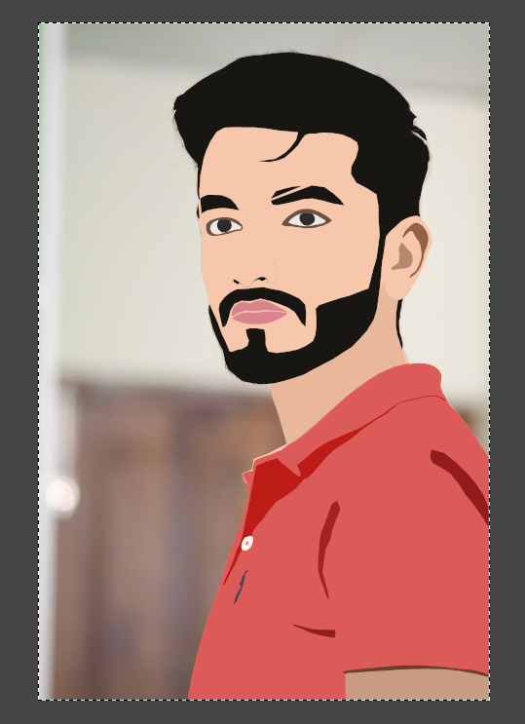
12. Do these for all the facial features and for the subject’s shirt.
13. To create shadows and highlights for our cartoon character move the source layer to top.
14. Add alpha channel.
15. Change the mode to overlay.
16. Reduce opacity to 50%.
17. Create a background.
18. Make path into selection and fill the background with background color.
19. Give some necessary finishing touches if required.

Your Cartoon Effect Self Potrait is ready.

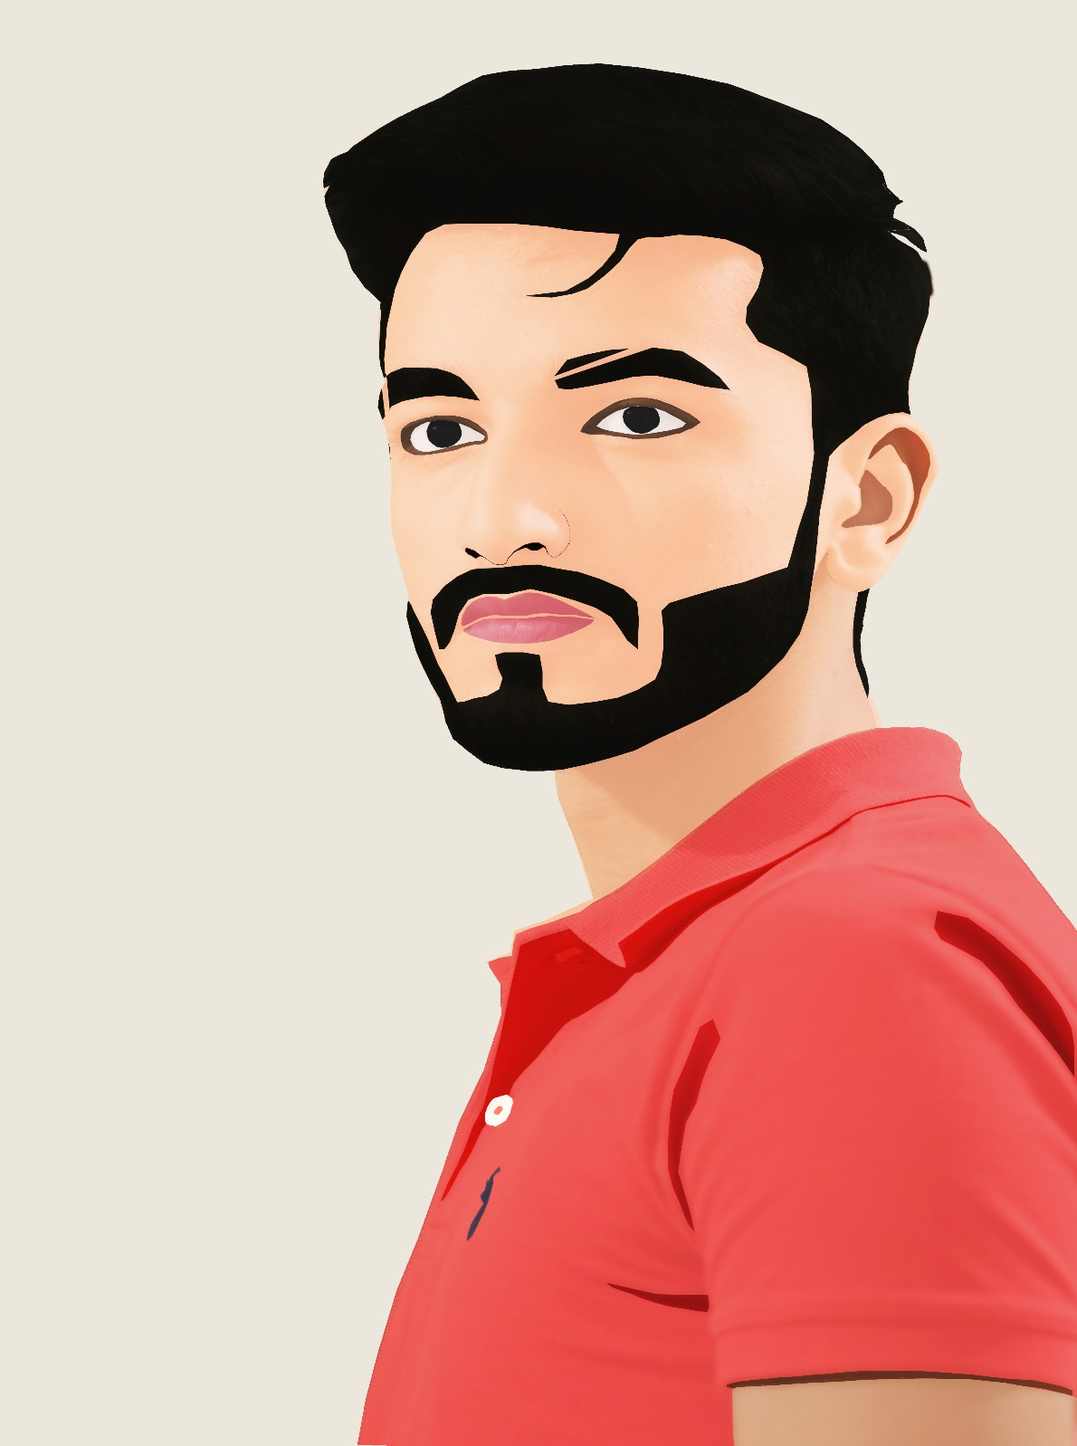

Q) IMPACT OF CHANNELS

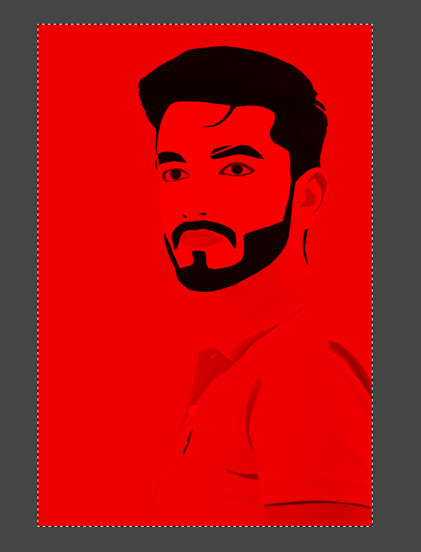

Using only the Red channel –

Using this channel highlights only the red colour in every pixel. Also, we can see the black color in image.The shadow on the tshirt faded.

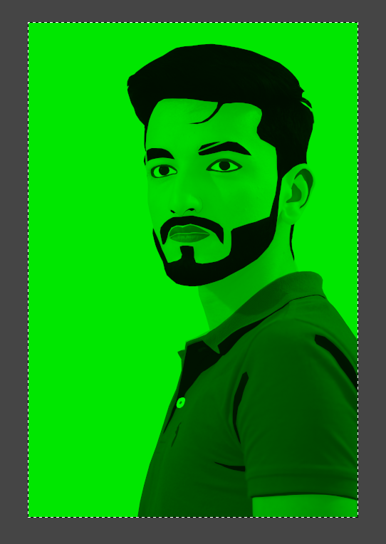

Using only the Green channel –

Using this channel highlights only the green colour in every pixel Also, we can see the black color in image. The color of tshirt is dark green.

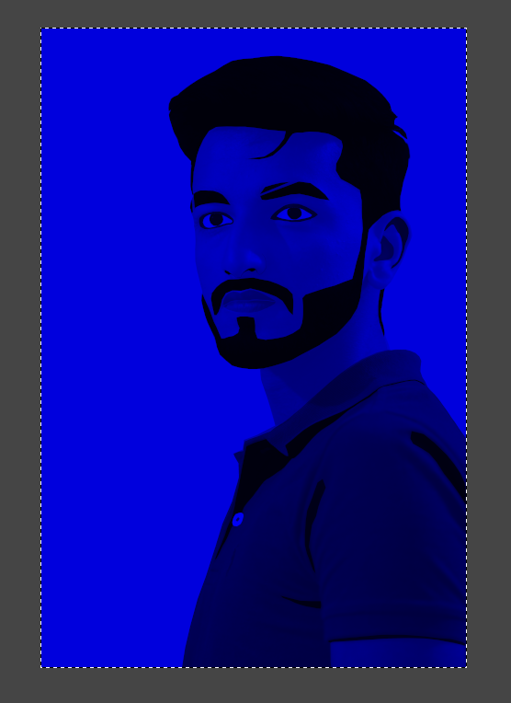

Using only the Blue channel –

Using this channel highlights only the blue colour in every pixel Also, we can see the black color in image. The color of tshirt is not blue.

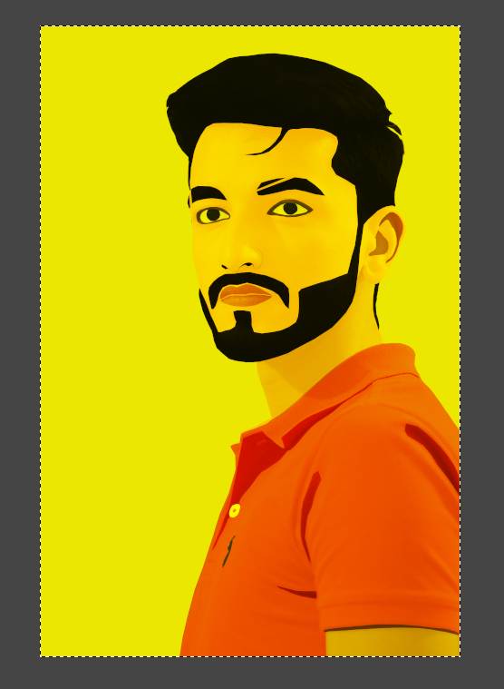

Using the Red and Green channel –

Using this channel highlights only the yellow colour in every pixel Also, we can see the black color in image. The image is quite close to the original. The color of tshirt matches with the original image.

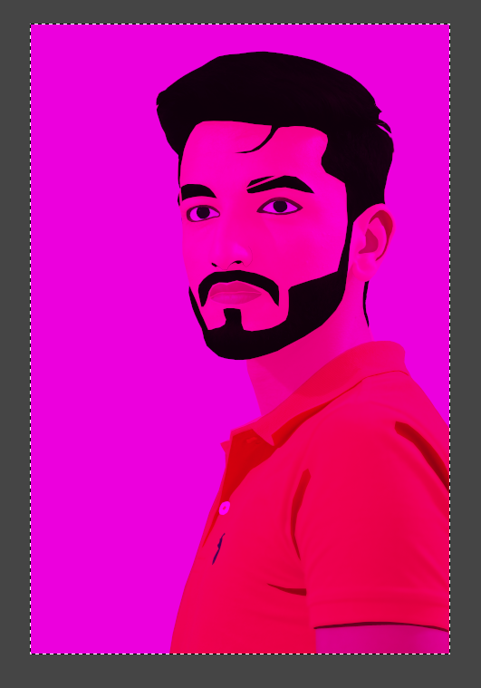

Using the Red and Blue channel –

Using this channel highlights only the purple colour in every pixel Also, we can see the black color in image. The color of tshirt matches with the original image. The color of the brand on the tshirt is blue.

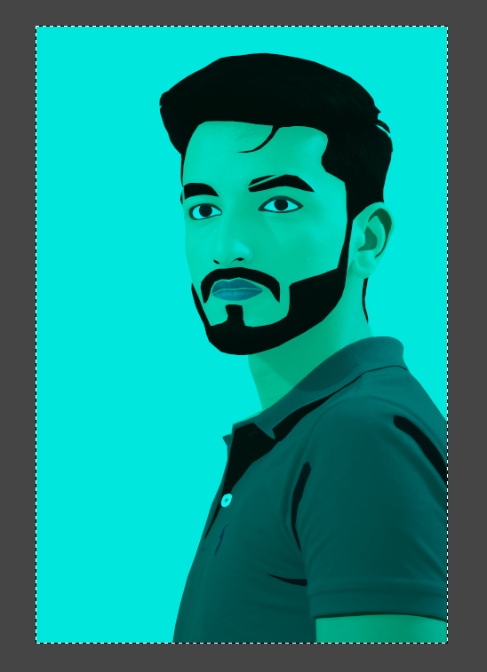

Using the Green and Blue channel –

Using this channel highlights only the cyan colour in every pixel Also, we can see the black color in image. The color of t-shirt is not cyan.